Data Structures and Algorithms  B. in Computer Engineering  B. in Robotics Engineering  Universidad Carlos III de Madrid  Course 2023-2024 | 

Group 89M. First Partial exam. March 12, 2024.

Name, Surname:…………………………………………………small group:

Instructions:
- Write your name on this exam sheet.
- The duration of the exam is 140 minutes.
- Mobiles must be switched off and can never be on the table.
- Use draft papers to prepare your solution. When you are satisfied, copy your final solution on this exam sheet.
- Take great care in the presentation of your solution. Your code must be clear, neat and tidy.
- You cannot ask your colleagues for a pen, pencil, etc. If you need something, ask the teacher for it.
- If you have a question, raise your hand and wait to be answered.
- You are not allowed to use Python's list or dictionary structures.
- When you finish, hand your exam sheet to the teacher. Do not hand in the draft papers. Throw them away or take them with you.

(0,75 points) Problem 1: In the following SList class, implement the function uniqueList that returns a new SList (other). The calling list (self) is a sorted SList with repeated elements. The new returned list must contain the same elements as the calling list (self) but without repetitions.

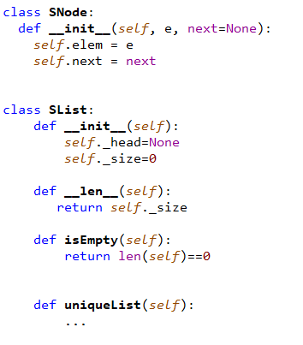

Examples:
self | other
empty | empty
1 | 1
1<->1<->3<->3<->5 | 1<->3<->5
1<->2<->2<->2<->5 | 1<->2<->5
1<->2 | 1<->2
1<->2<->2<->3<->3 | 1<->2<->3

(0,25 points) Estimate the order of complexity O(?) of the function uniqueList. Justify your answer.
(0,75 points) Problem 2: In the following DList class, implement a new method removeAlternate(). The method will keep the first node in the list and remove the next one. It will continue keeping one node, removing the next node. The method modifies the calling list (self). It doesn´t return anything. The complexity of the solution must be O(n).
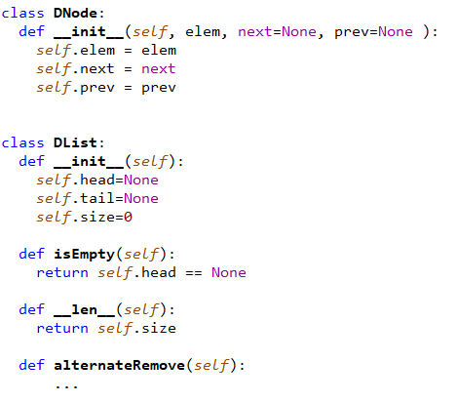

Examples:
Self before operation | Self after operation
empty | empty
1 | 1
1<->2 | 1
1<->2<->3 | 1<->3
1<->2<->3<->4<->5 | 1<->3<->5
1<->1<->3<->3<->5 | 1<->3<->5
1<->2<->2<->2<->5 | 1<->2<->5

(0,25 points) Estimate the order of complexity O(?) of the function uniqueList. Justify your answer.

